ADDITIONAL INSTRUCTIONS AND INFORMATION

University of Iowa Research Foundation
Invention Disclosure Form

Thank you for disclosing your invention/technology to the University of Iowa Research Foundation (UIRF). The UIRF’s mission is to assist and support inventors at the University of Iowa commercialize their inventions and other innovations.

This disclosure form is the first step in a process that could potentially lead to commercialization of your invention/technology. Completion of this form is very important and assists UIRF in multiple ways:

- This form acts as a written, dated record of your invention/technology.
- It also provides the UIRF with the information needed to fulfill any obligations UI owes to the granting organization—federal, state, foundation, corporate—that funded the research leading to your innovation.
- It provides the UIRF with the basic information to assess the commercial prospects of your invention and plan an intellectual property strategy.

It is important that you provide a comprehensive and complete invention disclosure so that UIRF can make an informed decision on whether or not to move forward with your invention. Text fields will expand—use as many lines as you need to adequately answer each question. If you have prepared documents that answer a particular question, you may reference those and attach copies. It will be very helpful if you can provide attachments in electronic form. Please complete this form to the best of your ability. Fully completed disclosures help expedite the process of understanding and properly evaluating you invention.

Submit your completed disclosure form (in Word format), along with any supporting documentation, electronically to UIRF at uirf@uiowa.edu.

Alternatively, you may submit an online invention disclosure directly to our Wellspring Sophia Database via our online portal located here:

https://uirf.research.uiowa.edu/our-process/submit-invention/

Upon receipt of the completed disclosure form, a UIRF licensing associate will be assigned and will contact you to arrange a meeting. The purpose of this meeting will be to acquaint you with UIRF's evaluation process, to gain a more comprehensive understanding of the invention/technology and to determine and define next steps. If you would like help completing this disclosure form, a UIRF licensing associate or disclosure manager would be happy to assist you; please contact them with your inquiry.

IDF Instructions

Below is a short glossary of terms that may clarify the IDF instructions and assist you in completing it. If you have more questions, please contact a member of the UIRF staff. Additional information is also available on the UIRF website at: https://uirf.research.uiowa.edu/

1. TITLE OF INVENTION
Create a short title describing the invention without revealing any specific details that would enable others to make and use it (that is, don’t give your key discovery away in the title).

2. BRIEF SUMMARY OF THE INVENTION
In layman terms, please give a brief overview (200 words max) of the invention innovation itself. Include how it is to be used and/or why it is useful. Briefly describe what makes the invention innovation new and unique.

3. FUNDING SOURCES
Through contracts with the University, most sponsors may have obtained intellectual property rights and thus require notification when an invention or other intellectual property is created. It is important, therefore, that all external sources of funding used in the creation of the invention, including contributors’ salaries (e.g., NIH or NSF grants), be reported to this office. The University requires this information in order to comply with the terms of your grant awards. Recent Bayh-Dole changes require both the grant number and award date to be compliant.

4. PUBLIC DISCLOSURE
Any of the following may be considered a public disclosure:

- Publication in a paper, or on the web
- Use of the invention in a public setting
- Written or oral presentations, such as at a conference, symposium or gathering; includes research posters
- Publication in a non-confidential federal grant proposal (when funded, it may become public)
- Non-federal funding proposals
- Thesis defense seminar
- Disclosure to a colleague at another institution, or to a collaborator at a private company, without a confidentiality agreement in place
- Distribution of tangible materials containing the invention without a confidentiality agreement
- Offer of the invention for sale

In the United States, the opportunity to obtain patent protection remains for one year after a public disclosure, use, or offer of sale. Outside the United States any public disclosure, use, or sale will immediately bar patent rights in most foreign countries.

Please include all past public disclosures and future planned public disclosures. Note that in some cases even the title of a publication alone may constitute a public disclosure if the title describes important aspects of the invention or enables someone with your skill and background to duplicate the invention without rigorous experimentation.

Please provide a copy of what you have presented or will be presenting. If you have a manuscript or abstract ready for submission describing the invention/creation, please forward a copy to us and identify the journal or conference where the manuscript will/did appear, including relevant dates. Be sure to include the dates and URL of any web publications, if you have them. Many times, abstracts and articles are posted to the web prior to the full online or print distribution.

It is very important that you inform us if you make plans for any additional public disclosures of this invention/creation after submitting this form.

5. AGREEMENTS & PROPRIETARY (NON-UI-OWNED) MATERIALS
Proprietary and non-UI-owned materials may include items received as a gift or obtained with or without a written agreement. “Strings” or conditions of use may also have been discussed in e-mail exchanges. Please attach any relevant emails or other documents such as licenses or material transfer agreements. Examples include:

- advanced materials that may have been used as base materials or substrates for surface modification, coating, or chemical or physical alteration
- animals, plants, and viruses
- catalysts
- cell lines
- combinatorial chemical libraries
- DNA materials including gene libraries, vectors, plasmids, and other sequences
- enzymes, monoclonal antibodies, and other proteins
- eukaryotic and prokaryotic cultures (animal and plant cell lines, yeasts, bacteria, and other microorganisms)
- fluorophores, labels, or "tags"
- microarrays
- open source software
- plasmids
- purification methods
- reagents
- RNA materials including RNA libraries
- software development tools

6. CONTRIBUTOR AFFILIATIONS

Invention contributors with affiliations and/or dual appointments with other institutions should report those affiliations to the UIRF. Affiliations should be reported even if the appointment is without compensation or the invention was not conceived or developed with the use of the other institution’s resources. The other institution may have obtained intellectual property rights to the invention and require notification when an invention is submitted to the UIRF. Examples of common contributor affiliations include VA or HHMI dual appointments. Please also include affiliations with startups or other companies as well.

7. INDUSTRY PARTNERS/POTENTIAL LICENSEES
Invention contributors often provide leads to potential licensees, which can greatly expedite the licensing process. Please list industries and particular companies that may be interested in your invention or could potentially benefit from the use of this technology. If you have any specific contacts within relevant companies, please list them as well.

8. DETAILED DESCRIPTION OF THE INVENTION

Please describe the invention in as much detail as possible. The invention must be sufficiently complete in technical detail to convey a clear understanding to the extent known at the time of the disclosure, of the nature, purpose, operation, and physical, chemical, biological, or electrical characteristics of the invention.

Start with what is the unique and novel or “new” feature. Include details on how to actually make, assemble, synthesize, or build the invention and details on how it is used once it is made. Include data, drawings, figures, supporting literature, your thoughts and logic behind it. If the invention involves chemistry or biology, provide evidence that the process or compound exists and functions in the way you describe.

9. STAGE OF DEVELOPMENT OF THE INVENTION

Unless previously stated in the invention description, describe the stage of development of the invention (e.g., concept stage, experimental stage, computer model simulation stage, working prototype stage). Providing us with this information helps the UIRF determine a timeline for evaluating the invention, including what resources may be necessary to make the innovation ready for marketing and intellectual property protection. If available, please include data, photographs, etc., indicating the stage of development.

10. EXISTING SOLUTIONS & PRIOR ART
Existing solutions may sometimes be referred to as "prior art" and refer to the existing body of technical information (some of which may be identified in scholarly works through literary searches) against which an invention is judged to determine if it is patentable (novel, non-obvious, and useful). Prior art includes publications and patents or other written documents that describe the invention as well as oral presentations of the invention or its sale or use in public, again by you or by others. Listing potential search keywords that relate to your technology may help uncover prior art and allow the UIRF to better evaluate our ability to obtain a patent on your innovation.

11. INVENTION CONTRIBUTOR DETAILS
If a faculty member, staff member, student, visiting scientist, or visiting scholar made his/her contribution to the invention while at UI (even if the person is no longer associated with UI), they are considered an UI Contributor. A current UI employee that made his/her contribution while employed elsewhere is NOT considered an UI Contributor and should list their organization during the time of their contribution.

Please be advised that contribution to an invention does not equal inventorship. Inventorship is a legal determination that will be made at the appropriate time(s) by a patent attorney. Individuals who solely provided funding, research materials, equipment, assistance in routine statistical analyses, assistance in routine testing, access to standard protocols, or individuals who bring to one’s attention the existence of a problem but not the solution are not inventors.

Although there is no legal significance to the order of names on a patent application or an issued patent, you may consult with the others who are likely to be inventors, and submit their names in the order you would prefer them to appear on a patent application, if one is filed. The UIRF cannot guarantee that the order presented in the IDF will result in an application or patent with names in the order originally presented. For communication purposes, the UIRF will assume the first invention contributor listed as the “lead” or primary point of contact.

Contributor College/Department/Center Designations
Effective January 1st, 2019 in accordance with changes to the University of Iowa Intellectual Property (IP) Policy, invention contributors may now identify which of their affiliated departments/colleges/labs/centers/etc. contributed to the creation of the invention and subsequently should receive a share of revenue generated from the commercialization of the invention (in accordance with UI IP distribution policy). Invention contributors may designate more than one department or center and split between them. The UIRF will notify the identified departments/colleges/labs/centers/etc. of the inventor’s selection.

A longer glossary and additional information can be found under the under the Researcher FAQs and Definitions and Terminology pages on the UIRF website: https://uirf.research.uiowa.edu/

INVENTION DISCLOSURE FORM (IDF)
______________________________________________________________________________________________________________________________________
For assistance, please call the University of Iowa Research Foundation (UIRF) at 319-335-4546 or email at uirf@uiowa.edu.

Information contained in this IDF is CONFIDENTIAL and PROPRIETARY. This IDF will normally not be released to others by UIRF except under attorney client privilege, to research sponsors as required by contract, under appropriate agreements, or as may be required by law. Please contact the UIRF before sharing this information with others. UIRF will work with you to accommodate your scholarly and other academic needs while protecting the intellectual property of your invention.
_______________________________________________________________________________________________________________________________________

- Title of Invention

An electrochemical catheter based on saline electrodilution for physiological flow measurement

- BRIEF SUMMARY OF THE INVENTION
In layman terms, please give a brief overview of the invention itself. Include how it is to be used and/or why it is useful.

The saline indicator-dilution based electrochemical pulmonary artery catheter leverages well-developed principles from electrochemistry and fluid mechanics for in vivo physiological flow measurement (e.g., cardiac output – the blood flow rate of the heart). Clinically, cardiac output is most often measured by thermodilution – where cold saline is injected into the flowing blood and the resulting changes in local blood temperature are used to estimate its flow rate. The saline indicator-dilution based electrochemical pulmonary artery catheter is a novel alternative to this method as it circumvents the unavoidable confounding factors related to temperature that lead to limitations in accuracy and reliability. The novel catheter retains operational similarity for flow measurement compared to the clinical-standard but is equipped with a microelectrode electrochemical cell at the distal tip that replaces the sensor physics for greater reliability. The electrochemical cell sensor operates using the principle of electrodilution to generate signals that are proportional to instantaneous changes in saline concentration of the physiological fluid (see Figure 1).

Figure 1: Schematic illustration of the electrodilution principle in the right-heart anatomy. The analyte bolus is released in the right atrium and mixes with the flowing blood. The distal electrochemical cell sensor detects changes in local concentration of the analyte-blood mixture over time. A model current envelope response to analyte injection at the different stages of electrodilution. (a) Injection of analyte tracer. (b) Initiation of the current response as the mixture reaches the electrochemical cell. (c) Peak current response to the injectate mixture. (d) Dilution by the continued flow of the medium. (e) Return to the baseline current.
This approach circumvents issues associated with using temperature and provides more robust data for signal analysis that may lead to more accurate flow estimates. The novel catheter has the full functionality of competitor pulmonary artery catheters used for thermodilution. From the perspective of the clinician, measurements made with the novel electrochemical catheter will be operationally identical to the clinical-standard method while eliminating the troublesome nature of dealing with temperature.

- Funding Sources

Was this invention funded/sponsored? | Yes No

If yes, list the funding source(s), and identify each source by contract or grant number and name the Principal Investigator / Supervisor.

FUNDING SOURCE / SPONSOR | CONTRACT OR GRANT NUMBER  & AWARD DATE | PRINCIPAL INVESTIGATOR / SUPERVISOR
National Institutes of Health | R03EB027299 | Dr. Syed Mubeen  Dr. Suresh ML Raghavan
UI Ventures GAP Fund | NA | Dr. Suresh ML Raghavan  Dr. Syed Mubeen
- PUBLIC DISCLOSURES
Have you or are you planning to write or talk about the invention publicly? Forms of public disclosure include abstracts, presentations, posters, dissertations or theses, proceedings, publications (including early online publication), public use of the invention, and discussions with people outside the University of Iowa.

If YES, please cite or briefly describe each instance of public disclosure, whether past or planned.
PUBLIC DISCLOSURE | DATE
Srivats Sarathy, Marco A Nino, Abdulsattar H Ghanim, Srinivasan Rajagopal, Syed Mubeen, ML Raghavan, “Electrochemical Approach to Measure Physiological Fluid Flow Rates “, Frontiers in chemistry, 9:680099, 2021  Note: We do not consider this article to be a public disclosure of this invention. The article laid out the basic principle but did not include the invention reported here, namely, the catheter designed based on the principle. The article is included nevertheless for consideration. | 6/16/2021

Please attach copies of any publications, abstracts, and presentations to this form.

- AGREEMENTS & PROPRIETARY MATERIALS
Please list all agreements that might affect any rights or interests in the invention. If any proprietary material (e.g., cell line, antibody, plasmid, computer software, or chemical compound) obtained from outside your laboratory was used to develop this invention, indicate below and list the name of the other party. Please attach copies of the agreements, if available.

TYPE OF AGREEMENT  (e.g., material transfer, confidentiality, consulting, sponsored research) | NAME OF OTHER PARTY

- CONTRIBUTOR AFFILIATIONS
If any of the contributors have an affiliation or dual appointment with another institution, even if the appointment is without compensation or the invention was not conceived with the use of the other institution’s resources, please indicate as such below.

ORGANIZATION | AFFILIATED CONTRIBUTORS
Veterans Administration (VA)
Howard Hughes Medical Institute (HHMI)
Other:

- INDUSTRY PARTNERS
List any companies that might be interested in your invention. If you are in contact with any companies or third parties that may want to license this technology, sponsor research, or collaborate with you and University of Iowa, please list their information.

COMPANY | CONTACT INFORMATION  (if applicable)
Edwards Life Sciences | Cordis
Baxter | Johnson and Johnson
Braun | ICU Medical

- DETAILED DESCRIPTION OF THE INVENTION

Please describe in as much detail as possible the invention itself. Start with what is the unique and novel or “new” feature. Include details on how to actually make, assemble, synthesize, or build the invention and details on how it is used once it is made. Include data, drawings, figures, supporting literature, your thoughts and logic behind it. If the invention involves chemistry or biology, provide evidence that the process or compound exists and functions in the way you describe.

The novel saline indicator-dilution based electrochemical catheter takes a unique approach to cardiac output measurement. With understanding of the electrochemical properties of blood, one can design an electrochemical sensor that retains the procedure operationally identical for the user while limiting the factors that lead to inaccuracies. By using principles from electrochemistry one can decidedly replace the sensor physics to the current clinical technique of measuring cardiac output. An electrochemical cell can be mounted to a pulmonary artery catheter using precious metal microelectrodes. The electrodes are strategically configured along the length of the catheter at the distal tip.

Electrodilution is operationally similar to thermodilution but leverages a different subset of physics to side-step the challenges associated with measuring changes in temperature. In electrodilution, when a voltage is applied to electrodes in contact with blood, the introduction and commixture dilution of a tracer will result in a charge transfer (faradaic process) and/or charge redistribution (capacitive process) and release a measurable change in the current magnitude. These temporal changes in current—current dilution—will be related to the blood flow rate because the greater the flow, the quicker the dilution.

For cardiac output measurements the catheter would be advanced into the right-heart anatomy, so the tip of the catheter sits in the pulmonary trunk (see Figure 1). Using a specific electrochemical technique, the electrodes are polarized, and the resulting current signal is recorded. A manual injection of saline analyte bolus would be made into the right atrium. The bolus would mix with blood and flow towards the electrochemical sensor. As the bolus passes over the sensor, a measurable response and recovery in the current signal is recorded. The strength of the response and its recovery time will be affected by the flow rate of blood. The signal response is then processed and used to estimate flow rate.
For what purpose will this invention be used?
The intended use of this device is to make flow rate measurement of any physiological fluid in or outside the body. Some specific areas of application are:
- Cardiac output measurement and monitoring (blood flow rate in the heart)
- Blood flow measurement in specific blood vessels in the circulatory system. E.g., coronary flow, cerebral flow, et.
- Blood flow measurement during extracorporeal flow. E.g., ECMO circuit flow, Blood flow for dialysis
- Cerebrospinal fluid (CSF) flow measurement. E.g., CSF flow in the spinal canal, CSF flow in shunt devices such as hydrocephalus shunt, etc.
- Flow of other physiological fluids such as pleural fluid flow from chest or urine flow.

What are the differences between your invention and existing solutions (novel, comparative benefits/advantages)?
Strategically replacing the sensor physics to the clinical-standard thermodilution approach avoids the sources of inaccuracies and troublesome aspects of using temperature changes as a proxy for cardiac output. The electrochemical sensor design is sensitive to changes in local analyte concentration – effects of temperature are negligible. In addition, the electrochemical signals produced are more robust; signals can be analyzed in the frequency domain to potentially increase sensitivity and specificity of our sensor.

- STAGE OF DEVELOPMENT OF THE INVENTION
Unless included above, describe the stage of development of the invention (e.g., concept stage, experimental stage, computer model simulation stage, working prototype stage, etc.). If available, please include data, photographs, etc., indicating the stage of development.

The saline indicator-dilution based electrochemical pulmonary artery catheter is currently in the working prototype stage. The device has been tested in high-fidelity in vitro and in vivo experiments. The saline indicator-dilution based electrochemical catheter was made by modifying a commercial pulmonary artery catheter intended for thermodilution. A 7.5Fr Swan-Ganz VIP Five Lumen Catheter (model 831F75) is adapted to be fitted with two platinum-iridium (Pt-Ir) microelectrodes at the distal end of the catheter. Figure 2 below shows a 3D computer model cross-section of the catheter prototype used. Insulated wire was used to provide electrical connection to the mounted Pt-Ir microelectrodes by leveraging an auxiliary lumen port. Only the Pt-Ir electrodes make contact with the flowing media.

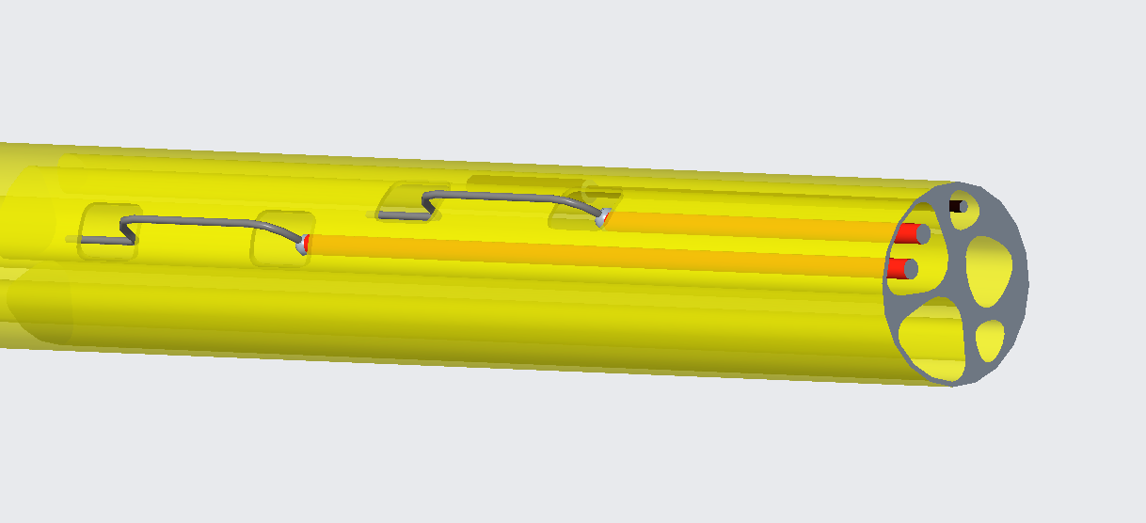
Figure 2: CAD model of the novel catheter showing the final configuration leveraging the RA infusion port lumen to mount the electrochemical sensor.
The two electrodes are used as a sensor by applying the electrochemical technique of large-amplitude sinusoidal voltammetry (with AC parameters of 2V_{pk}, 100Hz). When the polarized electrodes are in contact with flowing blood a measurable baseline current signal is measured. This electrochemical signal is sensitive to perturbations in local concentrations of analyte of the flowing blood at the vicinity of the electrodes. Therefore, controlled injections of hypertonic saline (7wt% NaCl) analyte bolus into the flowing blood can be used to induce a measurable change in the current signal that is proportional to cardiac output.

The novel electrochemical catheter prototype has been rigorously tested in high-fidelity in vitro experiments that mimic the physiological conditions the catheter will experience. Repeat injections of analyte bolus were made at different predetermined flow rates of bovine blood under pulsatile flow conditions. The data shown in Figure 3 below show the repeatability and flow sensitivity of the novel catheter. The area under the curve in the signal response is inversely proportional to the flow rate of the media.

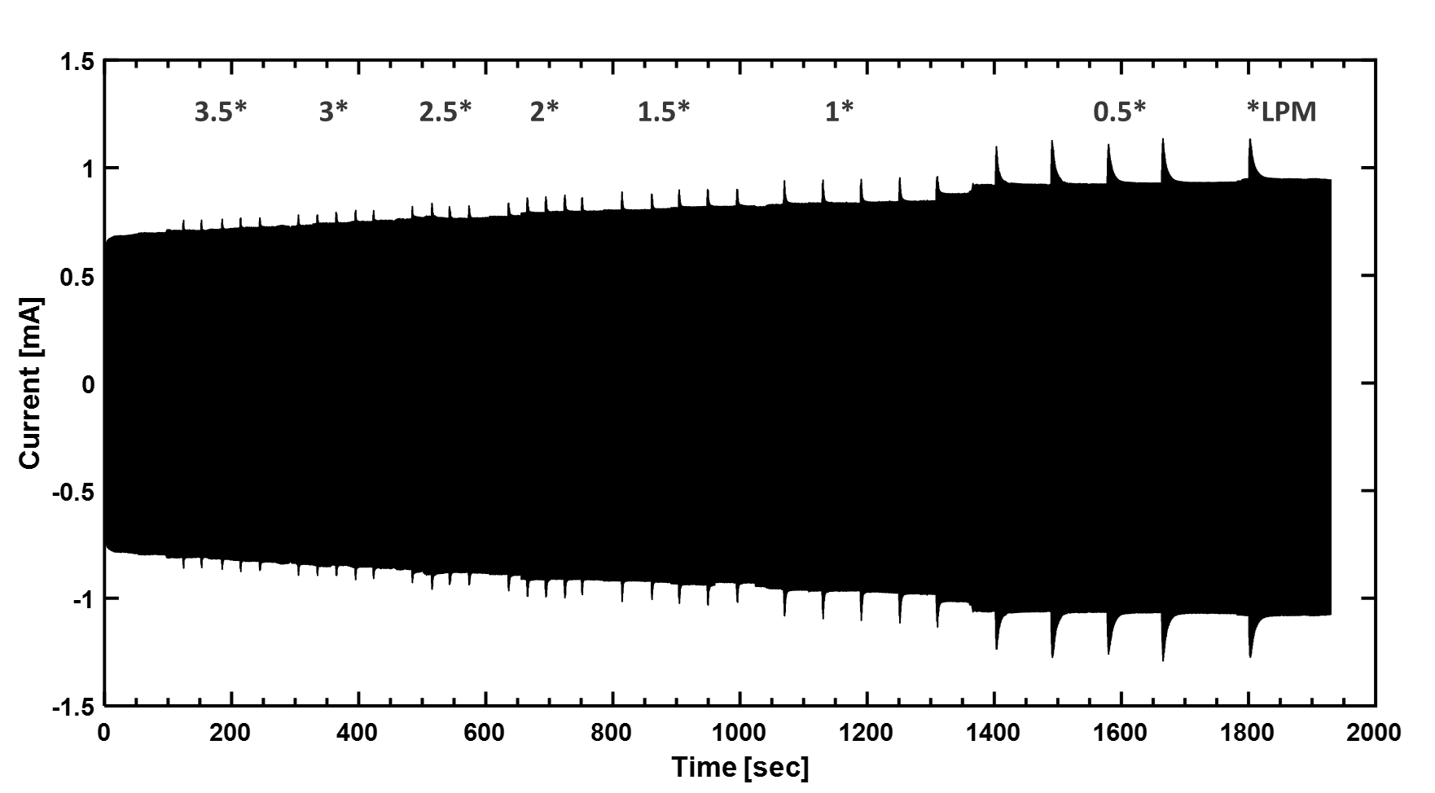
Figure 3: Example of data acquired from a high-fidelity benchtop experiment using anticoagulated bovine blood under pulsatile flow conditions. Five injections of analyte bolus were made at seven different controlled flow rates. Each spike in the signal a signal response to injection. Note the repeatability in signal response due to injection for a given flow rate and the change in signal response amplitude for different flow rtes.
Data from the in vitro experments (similar to data in Figure 3) were used to develop an automated alogirthm for signal processing and displaying the cardiac output estimate on-screen. Live-animal experiments (adult porcine model) have been performed to corroborate our in vitro observations and show that the electrochemical catheter can make cardiac output measurements in vivo (see Figure 4). This shows that saline electrodilution approach to cardiac output measurement is a feasible alternative to the clinical-standard technique while circumventing the known issues thermodilution.

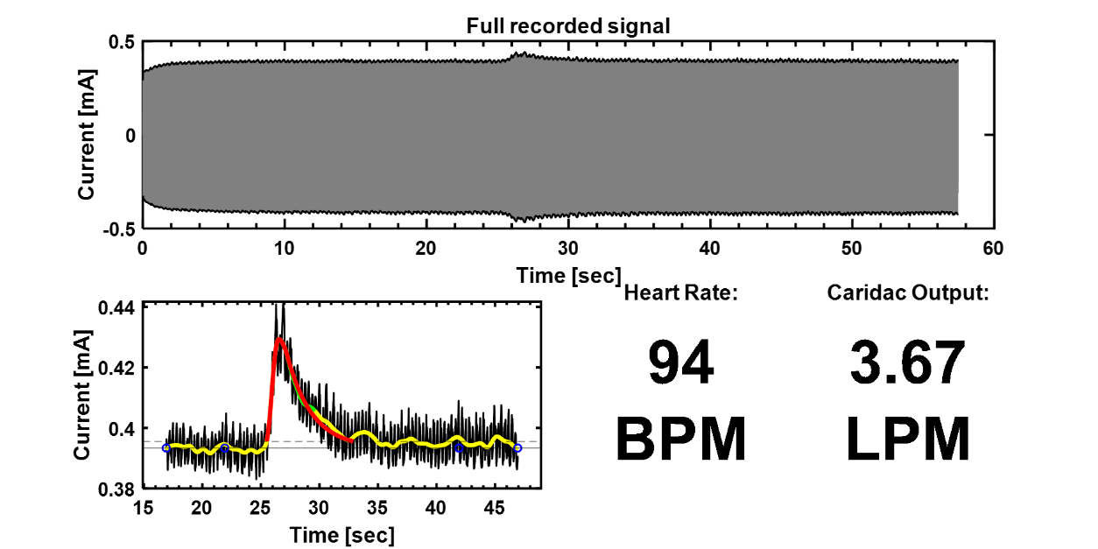
Figure 4: Example of the display output from the automated signal processing algorithm using data from an in vivo experiment. The output to the user includes the full signal acquired by the catheter during measurement, the isolated signal response to injection of saline, heart rate, and cardiac output estimate.
What are your immediate and future developmental or commercial steps/plans for the invention, and what is the approximate time frame for each?

By Nov 2023: Compare performance of saline electrodilution prototype with thermodilution catheter;
Submit invention disclosure.
By Jan 2023: File provisional patent
Submit manuscript for publication
By Apr 2023: Submit SBIR proposal
Perform additional animal model studies
Test device in additional applications such as blood flow in arteries, CSF flow, etc.
By Jun 2023: Pursue VC funding
Pursue first-in-human and clinical feasibility studies

- KEYWORDS / PATENT & LITERATURE SEARCH (OPTIONAL)
List any keywords that would help the UIRF identify the invention during a patent or literature search. If you have already performed a search, please attach your findings.

Thermodilution, Swan-Ganz catheter, cardiac output measurement, cardiac output monitoring, blood flow measurement, CSF flow

- Invention Contributors

The first person listed will be the “lead,” UIRF’s primary point of contact for the invention. Actual inventorship will be determined as a matter of law. UIRF royalties resulting from the commercialization of this invention will be split equally among the UIOWA inventors unless all inventors agree in writing otherwise. Invention contributors should list their affiliated departments/colleges/labs/centers/etc. which contributed to the creation of the invention (more than one may be listed, see instructions for more information). Add additional contributors as appropriate.
Lead:
Name:  Madhavan Lakshmi Raghavan | Employer:  University of Iowa | Position/Title:  Professor
Department:  Biomedical Engineering | Primary Email:  ml-raghavan@uiowa.edu | Primary Phone:  319 354 8357
Campus Address:  5605 Seaman’s Center, Iowa City, IA 52242 |  | Mobile Phone (optional):  319 354 8357
Home Address:  892 Forest Edge Circle, Coralville, IA 52241 |  | Citizenship:  US

Name:  Mubeen Syed Jawahar Hussaini | Employer:  University of Iowa | Position/Title:  Associate Professor
Department:  Chemical and Biochemical Engineering | Primary Email:  syed-mubeen@uiowa.edu | Primary Phone:  (805) 453-7859‬‬‬
Campus Address:  4139 Seaman’s Center, Iowa City, IA 52242 |  | Mobile Phone (optional):  (805) 453-7859‬‬‬
Home Address:  2350 Flintshire View, Coralville, IA 52241 |  | Citizenship:  India

Name:  Marco A Nino | Employer:  University of Iowa | Position/Title:  Graduate Research Assistant
Department:  Biomedical Engineering | Primary Email:  mnino46@yahoo.com | Primary Phone:  (909) 575-9660‬‬‬
Campus Address:  1430 Seaman’s Center, Iowa City, IA 52242 |  | Mobile Phone (optional):  (909) 575-9660‬‬‬
Home Address:  967 Sedona Ct, San Dimas, CA 91773 |  | Citizenship:  US

Name:  Abdulsattar H Ghanim | Employer:  University of Iowa | Position/Title:  Graduate Research Assistant
Department:  Chemical and Biochemical Engineering | Primary Email:  Sattar-alsaedi@uiowa.edu | Primary Phone:  319 333 2215
Campus Address:  Iowa Advance Technology laboratories, 205 N Madison St, Iowa City, IA, 52245 |  | Mobile Phone (optional):  319 333 2215
Home Address:  1936 Generry Dr., Coralville, IA, 52241 |  | Citizenship:  Iraq

